Caso 1

public IActionResult Authenticate(string user)
{
string query = "SELECT * FROM Users WHERE Username = '" + user + "'";

var userExists = false;
if (_context.Database.ExecuteSqlCommand(query) > 0) // Noncompliant
{
userExists = true;
}

return Content(userExists ? "success" : "fail");
}

Caso 2

public void Foo(DbContext context, string query, string param)
{
context.Database.ExecuteSqlCommand("SELECT * FROM mytable WHERE mycol=@p0", param);
}

Caso 4

<configuration>
<connectionStrings>
<add name="SqlServices" connectionString="Data Source=localhost;Integrated Security=SSPI;Initial Catalog=Northwind;" />
</connectionStrings>
<system.web>
<machineKey validationKey="D61B3C89CB33A2F1422FF158AFF7320E8DB8CB5CDA1742572A487D94018787EF42682B202B746511891C1BAF47F8D25C07F6C39A104696DB51F17C529AD3CABE"
decryptionKey="FBF50941F22D6A3B229EA593F24C41203DA6837F1122EF17" />
</system.web>
</configuration>

Caso 7

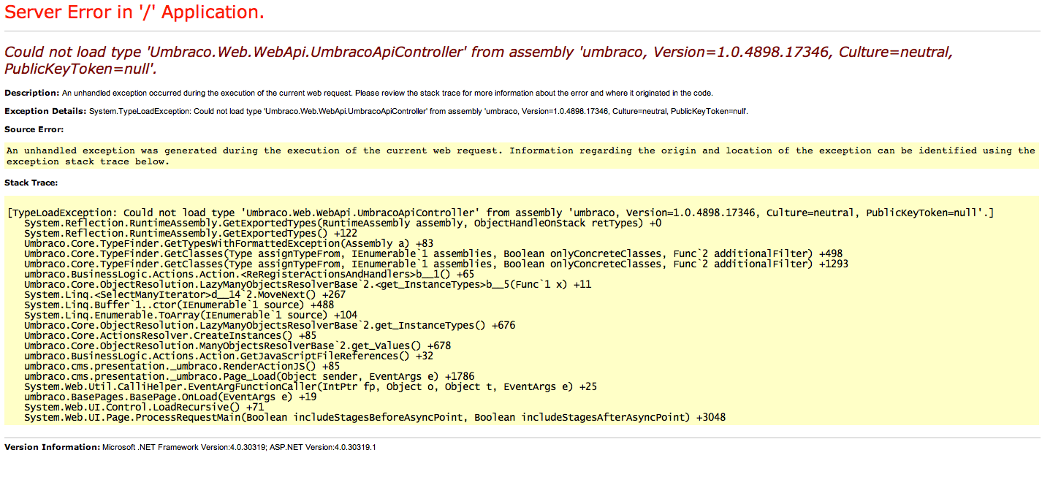

Caso 10

var mensaje = "";

try {
MetodoQueProvocaUnaExcepcion();
} catch (Exception ex) {
mensaje = "Error message: " + ex.ToString();

if (ex.InnerException != null) {
mensaje = mensaje + " Inner exception: " + ex.InnerException.Message;
}

mensaje = mensaje + " Stack trace: " + ex.StackTrace;
}

return mensaje;

Caso 11

<configuration>
<system.web>
<sessionState timeout="100"></sessionState>
</system.web>
</configuration>

